

Intellect Consulting Pvt Ltd

Your Enterprise, Our Priority

Response to RFI

Project Name: Marketing Call Center and CRM Module Integration

19 December 2025
V 1.0

Commercial in Confidence

Document Control

Version | Date | Change | Author
V 1.0 | 15 December 2025 | Initial Version | Prabodha Dissanayake

Document Distribution

Contact Name | Company | Email
Damith Rowel | Siyapatha Finance Plc | damithr@siyapatha.lk

Confidentiality Statement

This document and the information contained in it are provided in strict confidence for the sole purpose of proposing services and pricing and may not be disclosed to any third party or used for any other purpose without the express written permission of Intellect Consulting Pvt Ltd.

Statement of Commitment Against Corruption, Bribery and Extortion

Intellect Consulting Pvt Ltd is fully committed to conducting business with integrity and consistent with the highest ethical standards, and in compliance with all applicable laws and regulatory requirements for the prevention of corruption, bribery and extortion. Corrupt practices may subject the company and individual employees to potential criminal and civil liabilities. Corrupt practices may also adversely affect the reputation of Intellect Consulting as well as the confidence held by stakeholders, including our customers and business partners in our commitment to act professionally, fairly and with integrity in all our business dealings and relationships. In line with this commitment to maintain high ethical standards which are integral to our corporate identity and our business, it is Intellect Consulting’s policy to adopt a ‘zero-tolerance’ approach against all forms of corruption, bribery and extortion.

Company Details

Company Name | Intellect Consulting (Pvt) Ltd.
Business Registration Number | PV 00251617
Registered Address | 367/7/C, Thalangama North, Battaramulla, Sri Lanka 10120
Corporate Office | Level 4, No 192/10,9th Lane, Paramount Tower, Nawala, Sri Lanka 11222
Telephone | +94117598308
Email | connect@intellectconsulting.io
Website | www.intellectconsulting.io

Table of Contents

1. Executive Summary 7
2. Company Profile 8
2.1. Company Overview 8
2.2. Core Competencies and Services 8
2.3. Industry Experience 8
3. Technical Capabilities 9
3.1. Solution Overview -ConnectraCRM 9
3.2. CRM Capabilities 9
3.3. Call Center Integration 10
3.4. Integration Capabilities 11
3.5. Reporting and Analytics 12
3.6. Security and Access Control 12
3.7. Configuration and Extensibility 13
3.8. Scalability & Deployment Options 13
3.9. Technology Stack 13
3.10. Future Ready Capabilities 13
4. Implementation Approach 14
4.1. Delivery Methodology 14
4.2. Phased Implementation Approach 15
4.3. Highlevel Timeline 16
4.4. Infrastructure & Environment Setup 16
4.5. Training & Change Management 17
4.6. Governance and Communication 17
5. Support and Maintenance 17
5.1. Support Model 18
5.2. SLA Framework 19
5.3. Enhancement and Change Request Handling 19
5.4. Scalability, DR & Business Continuity 19
6. Commercials and Licensing 20
6.1. Licensing Model 20
6.2. Commercial Structure 20
6.3. Commercial Assumptions 21
7. Value Added Features and Roadmap 21
7.1. Value Added Features 22
7.2. Roadmap (Indicative) 23
7.3. Future Innovation Considerations 24
8. Indicative Cost Estimate 25
8.1. Implementation Cost (Indicative) 25
8.2. Payment Milestones (Indicative) 26
9. Assumptions and Dependencies 26
9.1. Key Assumptions 26
9.2. Dependencies 27
9.3. Scope Clarification Dependency 27
10. Conclusion and Next Steps 27

Executive Summary
Siyapatha Finance PLC is seeking a modern Marketing Call Centre and CRM solution to enhance customer acquisition, improve service quality, and gain better operational visibility across the organisation. Intellect Consulting understands the importance of establishing a strong digital foundation that supports both immediate business needs and long-term transformation goals.
Our proposed approach is to first implement a robust CRM platform as the core system of record. This will centralize lead management, customer information, and complaint handling while enabling consistent processes, accountability, and management reporting. Once the CRM foundation is established, we propose integrating it with Siyapatha’s existing call centre system to deliver a seamless end-to-end customer engagement experience. This phased approach minimizes risk, accelerates time-to-value, and ensures smoother organisational adoption.
Intellect Consulting brings extensive experience in digital transformation, having successfully delivered large-scale projects for both local and multinational organisations across multiple industries. Our team has proven expertise in handling complex fintech engagements in Sri Lanka and overseas, combining strong technical capability with deep business understanding.
We are committed to partnering with Siyapatha to deliver a scalable, secure, and future-ready customer engagement platform that supports measurable business outcomes and long-term growth.

Company Profile

Company Overview

Intellect Consulting (Private) Limited was established in 2022 as a digital transformation consulting company focused on delivering technology-driven business outcomes. The company supports organizations in modernizing their systems, processes, and customer engagement platforms through a combination of consulting, implementation, and managed services.

Core Competencies and Services
Intellect Consulting provides a broad range of technology and consulting services, including:
- Enterprise Solutions Consulting
- Digital Transformation Consulting
- CRM Solutions and Integrations
- Analytics and Business Intelligence
- Quality Assurance and Testing Services
- Product Engineering
- Artificial Intelligence (AI) and Automation Solutions
These capabilities enable Intellect to deliver end-to-end digital transformation initiatives, from strategy and design to implementation and support.

Industry Experience
Intellect Consulting has experience working with both local and multinational organizations across multiple industries. The company has been actively involved in delivering complex technology initiatives for enterprises in Sri Lanka, including organizations operating in regulated and process-driven environments.
In addition to cross-industry experience, Intellect brings growing expertise in the fintech domain, supporting initiatives that require strong governance, data integrity, and scalability.
2.4 Project Experience
Intellect Consulting is currently engaged in active and ongoing projects with several well-established local and multinational organisations, including:

Sri Lanka
- Sysco Labs Technologies ( a fortune 100 company)
- MAS Holdings
- Hayleys Advantis
- Prym Intimates Sri Lanka(JV between MAS Holdings and Prym Group, Germany)
- Ferentino Tyre Corporation
- Colombo Fort Group Services
- Lion Brewery

International

- Prym Intimates (Indonesia)
- Innova Apps (Spain)
- Fashionjust (Honkong)
- Cut and Dry (US)

These engagements demonstrate Intellect Consulting’s capability to deliver and sustain complex, enterprise-grade initiatives within structured governance environments.

2.5 Leadership Domain Experience

Relevant Domain Experience
Our delivery team brings strong banking and financial services domain experience. The Head of Delivery has over 15 years of experience in IT project delivery, with hands-on exposure across banking and financial institutions in Sri Lanka and Singapore. The engagement is further strengthened by a Lead Business Analyst with over 20 years of experience in one of Sri Lanka’s leading banks, with deep expertise in CRM and customer engagement platforms. The broader business analysis team also includes analysts with prior CRM experience in leading commercial banks.
This combined experience enables a strong understanding of regulated environments and the practical delivery of governed CRM solutions.

Technical Capabilities

Solution Overview -ConnectraCRM
ConnectraCRM is Intellect Consulting’s CRM solution built on a customizable open-source architecture, designed for enterprise and regulated environments. It is designed to support centralized customer engagement, structured lead management, and service operations while remaining flexible, scalable, and future-ready.
ConnectraCRM serves as the core system of record for customer interactions and is designed to integrate seamlessly with existing call centre platforms and other enterprise systems.

3.2 Golden Funnel – ConnectraCRM (Lead-to-Revenue Lifecycle)
ConnectraCRM supports a structured “Golden funnel” therefore Siyapatha Finance can manage every customer enquiry from first contact to final outcome in a consistent and measurable way.

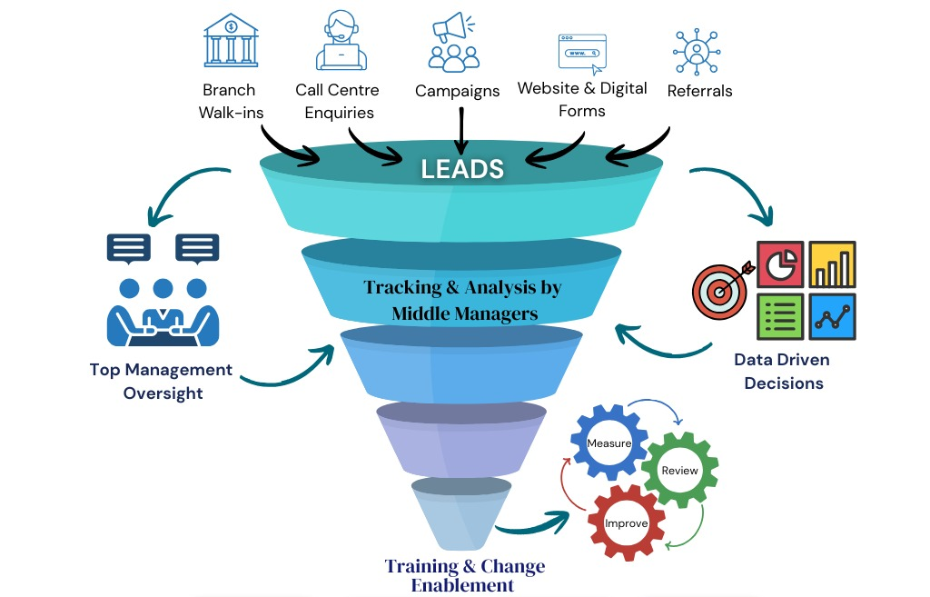

Lead Funnel Stages (ConnectraCRM)
- Lead Capture (Top of Funnel)
- Purpose: Capture every potential customer interest with minimal friction
- Typical sources: Call centre, branches, campaigns, website forms, referrals
- Stored in: Leads module
- Key details: Contact info, interest, source, basic notes
Goal: Ensure no potential customer is missed
- Lead Qualification
- Purpose: Confirm need and eligibility before sales effort increases
- Activities: Contact lead, verify intent, basic eligibility, timing
- Typical statuses: New → Contacted → Qualified / Disqualified
Goal: Separate real prospects from general inquiries
- Lead Conversion (Control Point)
- Purpose: Turn a qualified lead into structured CRM records
- Conversion creates:
  - Account (customer / organisation)
  - Contact (individual)
  - Opportunity (potential deal)
Goal: Move from inquiry to a tracked revenue pipeline
- Opportunity Pipeline (Sales Process)
- Purpose: Track opportunity progress, value, and expected close date
- Managed in: Opportunities module
- Example stages (customisable):
Qualification → Proposal → Approval → Negotiation → Closed Won / Closed Lost
Goal: Enable forecasting and active pipeline control
- Closed Outcome (Bottom of Funnel)
- Closed Won: Revenue achieved
- Closed Lost: Loss reason captured for improvement
Goal: Improve conversion over time using data-driven insights

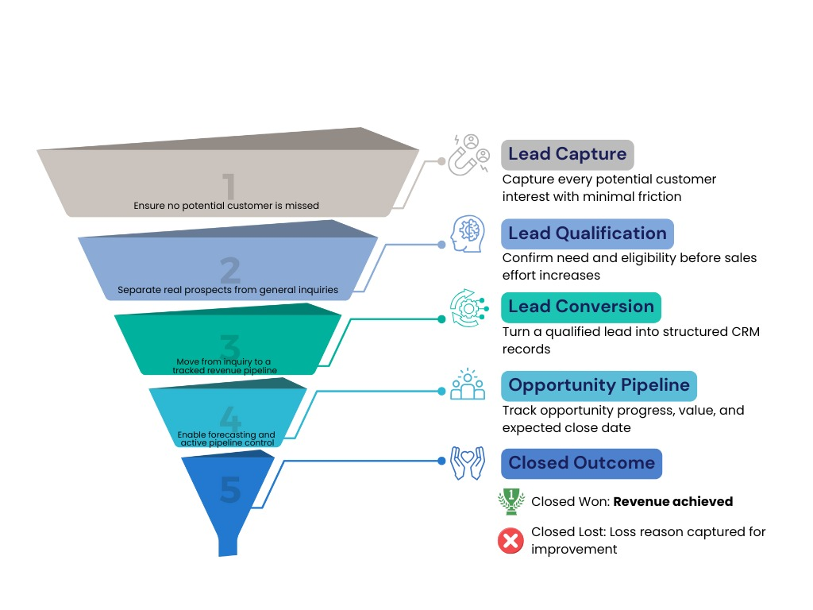

3.3 CRM Capabilities

ConnectraCRM provides a set of core CRM modules that can be configured to match Siyapatha Finance’s business processes. This supports standardisation across branches and teams, while still allowing flexibility for different products and workflows.

Core modules typically used in Siyapatha Finance context
- Leads
- Opportunities
- Customer 360 (Accounts + Contacts + Interaction history)
- Campaigns
- Cases & Complaints
- Tasks & Activities
- Dashboards & Reports
- Calls, Meetings, Notes & Attachments
- Notifications (Email/SMS integrations)
- Locations / Branch mapping
Additional modules (as needed)
- Targets
- Projects
- Knowledge Base

3.3.1 Customer 360° View
A Customer 360° View gives staff one place to understand the customer and their history before engaging them. This improves service quality and reduces repeat questioning. ConnectraCRM provides:

- Consolidated customer profile with contact details and segmentation
- Visibility of customer interactions across leads, calls, cases, and activities
- Historical engagement timeline for complete customer context
- Attachments and document management

3.3.2 Lead Management

Lead Management is the process of capturing enquiries from many channels, assigning them to the right teams, tracking follow-ups, and measuring conversion. ConnectraCRM supports:

- Multi-channel lead capture (call centre, branches(field and walk-in customers), campaigns, digital channels)
- Rule-based lead allocation (by product, branch, region, or team)
- Configurable lead lifecycle stages
- Automated follow-up reminders and task creation
- Escalation mechanisms for overdue leads
- Lead performance tracking and conversion reporting

3.3.3 Case and Complaints Management
Case and Complaints Management helps Siyapatha Finance
record complaints consistently, route them to the right teams, track SLAs, and measure service performance. ConnectraCRM supports:

- Centralized complaint intake and tracking
- Categorization by type, severity, and priority
- SLA tracking with automated escalations
- Assignment workflows across teams and departments
- Full audit trail from creation to closure
- Reporting on resolution timelines and service performance

3.3.4 Task and Activity Management

Task and Activity Management ensures every follow-up is owned, tracked, and visible to supervisors. ConnectraCRM supports:

- Structured task assignment and tracking
- Call logs, notes, follow-ups, and reminders
- User-level accountability and activity history

3.3.5 Opportunity (Pipeline) Management
Opportunity Management is used once a lead is qualified and converted. It allows Siyapatha Finance to manage sales stages, deal values, probability, expected close dates, and “won/lost” reasons. This supports forecasting, pipeline governance, and performance measurement at team/branch level.

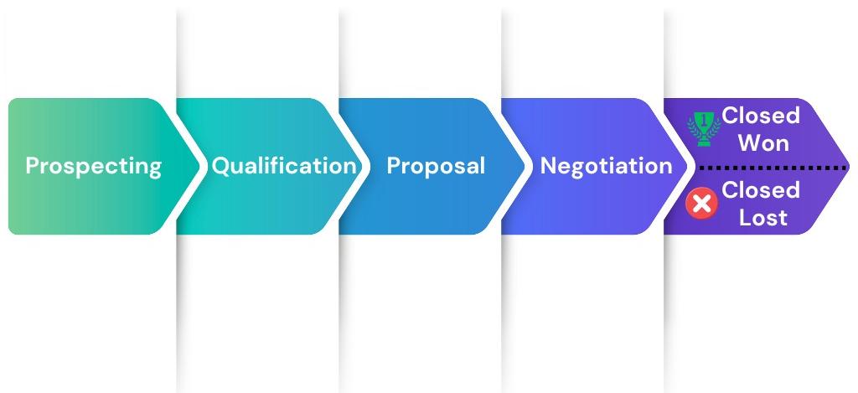

3.3.6 Admin Module
The Administration Module of ConnectraCRM provides centralized control over users, security, configuration, and governance settings. It enables Siyapatha to manage system access, enforce internal controls, and maintain operational discipline across all CRM users, including call centre agents, branch users, supervisors, and administrators.

Key administration capabilities include:
- User creation, modification, deactivation, and user ID locking
- Role-based access control to manage module-level and data-level permissions
- Password and login policy controls aligned with internal IT security standards
- Session management and access restrictions
- Audit logging of user activities and key system changes
- Configuration of workflows, approvals, and escalation rules
- Management of master data and system configurations
These controls support secure operations, segregation of duties, and audit readiness in a regulated financial services environment.

3.4. Call Center Integration

ConnectraCRM is designed to integrate with Siyapatha Finance’s existing call centre and IVR systems to improve agent efficiency and ensure every call is captured in CRM. Key capabilities include:
- Customer screen-pop based on inbound calls
- Call logging linked to leads, customers, or cases
- Automated creation of leads or cases from call outcomes
- Agent activity tracking and follow-up task generation
This approach allows Siyapatha Finance to keep the current call centre investment while increasing visibility and control through CRM.

If, during data analysis or discovery, Intellect team identifies that the current call centre setup is a bottleneck to achieving growth targets, Intellect Consulting can provide advisory support for a next-phase modernisation. This may include introducing a state-of-the-art, AI-driven call centre capability through Intellect’s affiliated company, Ventaz AI, such as AI IVR and intelligent call handling to improve productivity, customer experience, and measurable ROI. This modernisation can be positioned as a Phase 2 initiative, aligned to Siyapatha Finance’s operational readiness and transformation roadmap.

3.5 Integration Capabilities
ConnectraCRM supports integration with enterprise systems using standard and secure interfaces:
- API based integration
- Middleware-friendly architecture
- Integration with core finance systems, digital channels, SMS gateways, and email platforms
- Designed to support future integrations such as WhatsApp Banking and social media lead sources
- Active Directory based user authentication and authorisation

3.6 Reporting and Analytics
- Role-based dashboards for agents, supervisors, and management
- Lead pipeline and conversion analytics
- Complaint SLA and resolution tracking
- Branch and team performance reporting
- Exportable reports for management and compliance needs

3.7 Security and Access Control

ConnectraCRM is designed to support the security, governance, and regulatory expectations applicable to Non-Banking Financial Institutions (NBFIs) in Sri Lanka. The solution enables controlled access to customer and operational data through structured authorization mechanisms, ensuring that users can only view and perform actions relevant to their roles. Comprehensive audit trails provide traceability for critical activities, supporting internal controls and regulatory oversight. The platform can be deployed within Siyapatha Finance’s controlled infrastructure, allowing alignment with existing information security policies, data protection standards, and business continuity requirements mandated by the Central Bank of Sri Lanka (CBSL).

Key security and access control features include:
- Role-based access control (RBAC) to enforce segregation of duties
- Configurable data visibility based on role, function, or organizational unit
- Complete audit logs for user actions and system activities
- Secure authentication and authorization mechanisms
- Support for internal audits, compliance reviews, and investigations
- Deployment flexibility to align with existing IT security, DR, and governance frameworks
Compliance Note:
ConnectraCRM is designed to support regulatory and governance requirements; however, overall compliance with CBSL regulations, data protection laws, and internal policies remains subject to Siyapatha Finance’s governance framework, operational controls, and infrastructure standards. Intellect Consulting will work closely with Siyapatha Finance’s IT, Risk, and Compliance teams to align the solution with applicable regulatory and internal requirements.

3.8 Configuration and Extensibility
- Highly configurable data models, fields, and layouts
- Workflow automation using rules and triggers
- Ability to introduce new modules or processes without core code changes
- Support for UI/UX enhancements through theming and custom views

3.9 Scalability & Deployment Options
- Deployable on on-premise or private cloud infrastructure
- Scalable architecture suitable for enterprise usage
- Supports Dev, UAT, and Production environments
- Designed for phased rollout and future expansion

3.10 Technology Stack
- Platform: Open-source CRM platform, extensible and vendor-neutral

- CRM Solution: ConnectraCRM by Intellect Consulting
- Backend: PHP-based application layer
- Database: Relational database (MySQL / MariaDB compatible)

- Integration Layer: RESTful APIs
- Frontend: Web-based UI with customizable themes
- Hosting: On-premise or private cloud

3.11 Future Ready Capabilities
ConnectraCRM is designed with a future-ready architecture that allows Siyapatha Finance to progressively adopt advanced digital and AI-driven capabilities as part of its broader transformation journey. The platform provides a strong foundation to introduce intelligent automation and decision-support features while maintaining governance, control, and regulatory alignment.
Future enhancement possibilities include the introduction of AI-assisted capabilities, such as conversational interfaces and intelligent assistants that can support users in accessing information, summarising customer interactions, and improving response quality. These capabilities can be designed to operate within defined security and data access boundaries, ensuring sensitive financial data remains protected.
Potential future-ready capabilities include:
- AI-assisted customer interaction summaries and insights for call centre and branch users
- Intelligent search and query capabilities across customer, lead, and case data
- Automated suggestion of next best actions based on historical interactions and defined rules
- AI-assisted drafting of customer communications, subject to approval workflows
- Advanced analytics and predictive insights to support lead prioritisation and service optimisation
- Gradual introduction of conversational interfaces for internal users, aligned with governance and compliance requirements

These capabilities can be introduced in a phased and controlled manner, ensuring alignment with Siyapatha Finance’s organisational readiness, regulatory obligations, and long-term digital roadmap.

3.11.1 Mobile App Enablement for Digital Customer Engagement (Future Enhancement)
As part of Siyapatha Finance’s future-ready digital roadmap, ConnectraCRM can serve as a strong foundation to enable a customer-facing mobile application that connects directly with CRM processes. A mobile channel helps Siyapatha Finance to engage younger and digitally active customer segments through more frequent, convenient, and personalised interactions, supporting an industry-aligned digital journey while keeping customer data and interaction history governed within the CRM.
How a mobile app improves CRM reachability and engagement
- Direct digital communication: Secure in-app messages, push notifications, and alerts linked to CRM events (e.g., application updates, appointment reminders, document requests).
- Always-on customer touchpoints: Customers can check status, respond faster, and complete actions without visiting a branch or calling the call centre.
- Better service experience: Simple self-service features (FAQs/knowledge base, request logging, appointment booking) integrated with CRM cases and activities.
- Higher conversion and retention: Campaigns, offers, and product education can be targeted using CRM segmentation and engagement history.
- Unified customer view: All mobile interactions are captured back into the
Customer 360 timeline, improving visibility for call centre and branch staff.
In summary, a mobile app layer—powered by ConnectraCRM—can help Siyapatha Finance increase digital adoption, strengthen customer engagement, and reduce service friction. This capability can be implemented in phases, aligned to Siyapatha Finance’s product priorities, security and compliance requirements, and operational readiness.

Implementation Approach

Intellect Consulting follows a structured and phased implementation approach to ensure predictable delivery, strong governance, and smooth organisational adoption. The approach focuses on establishing a solid CRM foundation first, followed by controlled integration with existing systems, minimising operational risk while enabling early business value.

Delivery Methodology
The implementation will follow a phased and iterative delivery methodology, combining structured planning with incremental validation. This approach ensures early visibility, continuous stakeholder engagement, and timely risk identification.
Key principles of the delivery approach include:
- Clear scope definition and governance
- Phased rollout to reduce operational disruption
- Regular validation with business users
- Early focus on adoption and usability
- Alignment with regulatory and internal control requirements

Phased Implementation Approach

Phase 1 – Initiation and Planning
- Project kickoff and governance setup
- Confirmation of scope and success criteria
- Finalisation of project plan and timelines
- Environment planning and access setup
Phase 2 – Detailed Requirement and Solution Design
- Detailed business requirement workshops
- CRM process design for lead management, customer management, and complaint handling
- Integration design with the existing call centre system
- Reporting and dashboard design
- Security and access model definition
Phase 3 – Configuration and Build
- Configuration of ConnectraCRM modules
- Workflow and automation setup
- Integration development and configuration
- Report and dashboard configuration
- Unit testing and internal validation
Phase 4 – Testing and User Acceptance
- System integration testing
- User Acceptance Testing support
- Issue resolution and refinements
- UAT sign-off
Phase 5 – Go Live and Stabilisation
- Production deployment
- Go live support
- Post go live stabilisation and monitoring
- Knowledge transfer and handover

Highlevel Timeline

The overall implementation timeline will be confirmed following detailed requirement workshops. A phased rollout is expected to enable early adoption while managing change effectively.
A high-level indicative timeline will be shared during the next stage based on finalised scope and integration complexity.

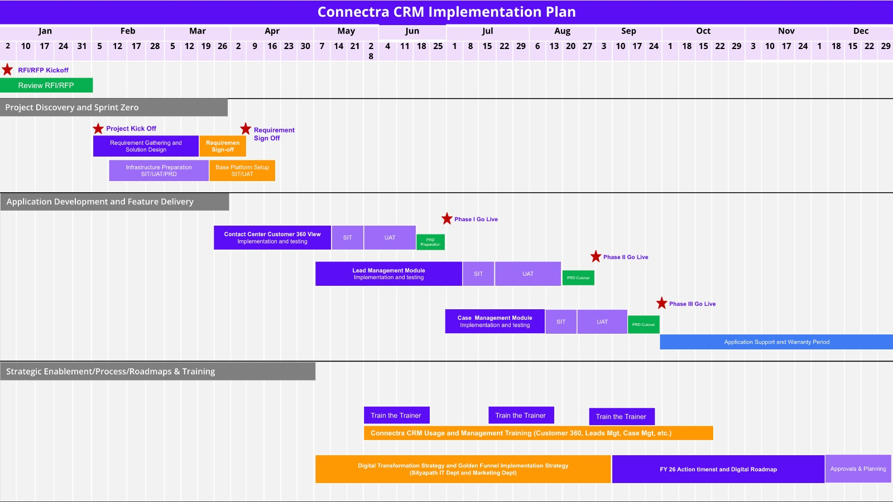

Infrastructure & Environment Setup

- Support for multiple environments including Development, UAT, and Production
- Deployment within Siyapatha’s designated infrastructure or approved hosting environment
- Coordination with Siyapatha IT teams for access, security, and deployment standards
- Alignment with existing IT governance and change management processes

Training & Change Management

User adoption is a critical success factor for any CRM initiative. Intellect Consulting will support structured training and change enablement activities to ensure users are confident, capable, and comfortable using the system as part of their day-to-day operations.
The training and change enablement approach will focus on building practical understanding, encouraging early adoption, and minimising disruption during rollout. Key activities will include:
- Role-based training sessions tailored to different user groups (e.g. relationship officers, supervisors, managers, and administrators), focusing on real-life usage scenarios
- System walkthroughs and guided demonstrations covering key CRM processes, supported by user guides and reference materials
- User Acceptance Testing (UAT) participation, enabling business users to validate workflows, provide feedback, and build early ownership of the solution
- Change communication and adoption support to help users understand new processes and benefits
- Post–go-live support during the stabilisation period, including issue resolution and usage guidance to ensure a smooth transition into business-as-usual operations
This approach ensures that the CRM solution is not only successfully implemented, but also effectively adopted and embedded within Siyapatha Finance’s operational processes.

Governance and Communication

- Defined project governance structure
- Regular status and progress reporting
- Issue and risk tracking
- Steering committee and review meetings as required
This ensures transparency, accountability, and alignment throughout the project lifecycle.

Support and Maintenance

Intellect Consulting provides structured post-implementation support and maintenance services to ensure the stability, performance, and continuous improvement of ConnectraCRM. Support services will be delivered through a dedicated service desk to provide clear visibility, traceability, and timely resolution of incidents and requests.
A formal support desk will be established using Freshdesk, enabling Siyapatha users to log, track, and monitor support requests in a structured and transparent manner. This approach ensures consistent service delivery, proper escalation, and comprehensive reporting for operational and management oversight.

Support Model
Intellect Consulting follows a tiered support model supported by a centralized service desk.
Support Desk Platform:
- Freshdesk will be used as the official support desk for incident and request management
- All issues, queries, and requests will be logged and tracked through the Freshdesk portal
- Ticket history, status, and SLA tracking will be available for transparency and reporting
Support Levels:
- Level 1 (L1):
User queries, basic troubleshooting, and initial issue triage
- Level 2 (L2):
Application configuration issues, functional analysis, and CRM process support
- Level 3 (L3):
Advanced technical support, defect resolution, and complex system issues
Support Channels:
- Freshdesk portal
- Email based ticket creation
- Scheduled review and governance meetings
Support coverage and operating hours will be agreed based on Siyapatha’s operational needs.

SLA Framework
Service Level Agreements will be configured and monitored through Freshdesk, enabling real-time visibility into response and resolution performance.
Indicative SLA Categories:
- Critical: System unavailability or major business impact
- High: Significant functional impact with limited workarounds
- Medium: Partial impact affecting some users or processes
- Low: Minor issues, usability concerns, or general inquiries
Response and resolution targets will be defined for each category and tracked via the service desk to ensure consistent service levels and accountability.

Enhancement and Change Request Handling
Enhancements and change requests will be managed through a controlled change management process and logged via the Freshdesk service desk for traceability.
Change Handling Process:
- Formal submission of enhancement or change requests
- Impact analysis covering scope, effort, timeline, and risk
- Review and prioritisation in collaboration with Siyapatha stakeholders
- Approval before implementation
- Controlled deployment and post-implementation validation
This ensures all changes are delivered in a predictable and auditable manner without disrupting ongoing operations.

Scalability, DR & Business Continuity

ConnectraCRM is designed to support enterprise scalability and business continuity requirements. The solution can be scaled to support growth in users, data volumes, and functional scope.
Key considerations include:
- Support for multiple environments (Development, UAT, Production)
- Scalability to support additional users, branches, and operational units
- Backup and recovery mechanisms aligned with internal IT policies
- Support for Disaster Recovery setups based on customer infrastructure
- Alignment with existing business continuity and DR frameworks
Intellect Consulting will work closely with Siyapatha’s IT and infrastructure teams to ensure deployment and recovery strategies align with regulatory, governance, and operational requirements.

Commercials and Licensing

Licensing Model
ConnectraCRM is built on SuiteCRM, which is a free and open-source CRM framework. As such, the CRM solution will be provided to Siyapatha under a perpetual license, with no recurring software licensing fees or per-user charges.
Siyapatha will have the right to use the deployed CRM solution indefinitely within its organization. Any configurations or customizations delivered as part of the engagement will be made available to Siyapatha in accordance with the applicable open-source licensing model of the underlying platform.

Commercial Structure
While the CRM platform itself is licensed on a perpetual basis, ongoing support and maintenance services will be provided by Intellect Consulting under a separate commercial arrangement.
The overall commercial structure will consist of:
- One-time CRM implementation and configuration services
- Customisation and integration services
- Training and change enablement
- Annual support and maintenance services delivered by Intellect Consulting
- Enhancements and change requests on demand
This model ensures Siyapatha benefits from long-term ownership of the CRM solution while relying on Intellect Consulting for expert support and continuous improvement.

Commercial Assumptions

- The CRM solution will be deployed within Siyapatha’s designated infrastructure
- Ongoing support and maintenance services will be provided by Intellect Consulting
- Infrastructure and hosting costs are assumed to be managed by Siyapatha unless otherwise agreed
- Any third-party tools or services, if required, will be identified and priced separately
- All commercials provided at the RFI stage are indicative and subject to final scope confirmation

Commercial Disclaimer
All commercial information provided at this stage is indicative and non-binding, intended solely for evaluation and budgetary planning purposes as part of the RFI process. Final commercials will be subject to detailed scope definition, technical validation, and mutual agreement.

Value Added Features and Roadmap
ConnectraCRM is designed not only to meet current operational requirements but also to support Siyapatha’s long-term digital transformation roadmap. Beyond core CRM and call centre integration, the platform enables the introduction of value-added capabilities that enhance efficiency, customer experience, and decision-making in a controlled and phased manner.

Value Added Features
Omnichannel Customer Engagement
ConnectraCRM enables centralised management of customer interactions across multiple channels including call centre, branches, email, web forms, and future digital channels. This ensures a consistent customer experience and a complete interaction history across all touchpoints.
WhatsApp Banking Enablement (Future-Ready)
ConnectraCRM can serve as the backend engagement and orchestration layer for WhatsApp-based customer interactions. This allows Siyapatha to introduce WhatsApp Banking capabilities in a controlled and phased manner, enabling customers to engage through a familiar channel while maintaining governance and visibility.
Potential WhatsApp Banking use cases include:
- Lead capture and service requests initiated via WhatsApp
- Automated responses for common inquiries
- Routing of complex requests to call centre or branch teams
- Logging WhatsApp conversations within the customer interaction history
- Triggering follow-up tasks and service workflows
Advanced Reporting and Management Dashboards
Enhanced dashboards provide real-time visibility into lead performance, service SLAs, complaint resolution, and branch or team productivity, supporting data-driven decision-making.
Workflow Automation and Process Standardisation
Automation of lead allocation, follow-ups, SLA escalations, and approvals helps improve operational discipline, reduce manual effort, and ensure consistency across teams.
Customer 360° Insights
A consolidated customer view combining interactions, service requests, and engagement patterns supports improved service quality and more informed business decisions.

Roadmap (Indicative)
Phase 1 – Foundation
- CRM core implementation
- Lead management and complaint management
- Integration with existing call centre system
- Standard dashboards and reporting
Phase 2 – Optimisation
- Enhanced dashboards and analytics
- Improved automation and workflow optimisation
- Integration with additional digital channels
- User experience and usability enhancements
Phase 3 – Intelligence and Automation
- AI-assisted insights such as lead prioritisation and service trend analysis
- Intelligent suggestions for next best actions
- Conversational and assisted interfaces for internal users
- Advanced analytics and predictive reporting

Future Innovation Considerations
Future enhancements can be introduced progressively based on organisational readiness and regulatory alignment, including:
- AI-assisted user support and knowledge access
- Intelligent summarisation of customer interactions
- Predictive insights to support marketing and service strategies
- Enhanced self-service capabilities for internal users
All roadmap items can be evaluated and implemented in collaboration with Siyapatha’s business, IT, and compliance teams to ensure alignment with governance and regulatory requirements.

Future Customer Mobile App (CRM-Enabled Digital Engagement & Banking Services)
As a future enhancement, Siyapatha Finance can introduce a customer mobile app that is tightly connected with ConnectraCRM to deliver a modern, always-on digital experience. The app can combine product discovery and engagement with core finance servicing features, helping Siyapatha attract younger customer segments and keep them engaged through convenient, personalised, and secure interactions.
How the app can leverage CRM to promote products and improve conversion
- Personalised product offers: Show relevant loan/savings/finance products based on customer profile, life stage, and interaction history stored in CRM.
- Digital lead capture: Customers can submit enquiries or applications in-app, automatically creating leads/opportunities in CRM with complete context.
- Campaign reachability: Push notifications and in-app messages driven by CRM campaigns and segmentation to increase response rates.
- Next-best-action journeys: Guided steps and reminders (documents needed, appointment scheduling, follow-ups) linked to CRM activities.
Banking and servicing functionalities to increase engagement
- Application and request tracking: Customers can view application status, next steps, and required documents in real time.
- Self-service support: Log requests/complaints in-app, track SLAs, and chat with support—creating cases directly in CRM.
- Account and repayment services: View balances, instalment schedules, payment reminders, and enable digital repayments (via integrated payment gateways).
- Secure communication: Two-way messaging with call centre/branch staff and document upload with audit trails.
By combining CRM-driven personalisation with practical finance servicing features, the mobile app can become a key channel for customer acquisition, retention, and service efficiency. Implemented in phases, this initiative can support Siyapatha’s digital transformation to an industry-aligned standard while maintaining governance, security, and compliance expectations.

Indicative Cost Estimate

The following cost estimates are provided at a high level for indicative and budgetary purposes only, based on our current understanding of the requirements outlined in the RFI. Final costs will be subject to detailed requirement confirmation, solution scope finalisation, integration complexity, and commercial discussions.

Implementation Cost (Indicative)
The one-time implementation cost includes:
- CRM configuration and setup using ConnectraCRM
- Lead management and complaint management workflows
- Integration with the existing call centre system
- Reporting and dashboard configuration
- User training and go-live support
Indicative Range:
Cost Component | Description | Indicative Amount (USD)
CRM Implementation | ConnectraCRM setup, configuration, workflows, dashboards, and call centre integration | 60,000 – 80,000
Annual Support & Maintenance | L1/L2/L3 support via Freshdesk, SLA monitoring, minor configuration support | To be proposed separately
Optional / Future Enhancements | WhatsApp Banking, advanced analytics, AI-assisted capabilities, additional integrations | To be estimated separately

Payment Milestones (Indicative)

The implementation cost will be invoiced based on milestone completion to ensure transparency and alignment with delivery progress.

Milestone | Description | Payment %
Project Initiation | Contract execution, formal project kickoff, and completion of agreed environment setup | 20%
Solution Design & Configuration Complete | Core CRM configuration, workflows, and initial integrations completed | 30%
Ready for User Acceptance Testing (UAT) | Solution ready for business UAT | 20%
Go Live | Production deployment and system go live | 20%
Post Go Live Stabilisation | Completion of post go live support and stabilization period | 10%

Key Cost Assumptions

- Costs are based on the scope outlined in the RFI and initial discussions
- Infrastructure and hosting costs are excluded unless otherwise agreed
- Third-party services, if required, will be priced separately
- Final pricing and milestones will be confirmed after detailed requirement workshops

Cost Disclaimer

All pricing and milestones are indicative and non-binding, intended solely for evaluation and planning purposes as part of the RFI process.

Assumptions and Dependencies
This section outlines the key assumptions and dependencies considered while preparing this RFI response. These assumptions help set a common understanding and will be validated and refined during subsequent project phases.

Key Assumptions
- Siyapatha will nominate key business and IT stakeholders to participate in requirement clarification, design reviews, and UAT activities.
- Business requirements provided during the RFI stage represent a high-level view and may evolve during detailed requirement workshops.
- Required access to existing systems, documentation, and environments will be provided in a timely manner to support integration and testing activities.
- Infrastructure and hosting for the CRM solution will be provided and managed by Siyapatha unless otherwise agreed.
- Users participating in UAT and training will be available as per the agreed project plan.
- Any data migration requirements, if applicable, will be limited to scope agreed during detailed design.

Dependencies
- Integration with the existing call centre and IVR systems is dependent on the availability of technical documentation, APIs, and support from the respective vendors.
- WhatsApp Banking and other advanced digital channels are subject to regulatory alignment, business readiness, and third-party service availability.
- Timely decision-making and approvals from Siyapatha stakeholders are required to maintain the proposed project timelines.
- Any changes in scope, regulatory requirements, or integration complexity may impact delivery timelines and commercials.
- Third-party tools or services, if required, will be subject to separate commercial and contractual arrangements.

Scope Clarification Dependency
- Final scope, timelines, and commercials will be confirmed after detailed requirement workshops and technical validation.
- This RFI response is based on the information available at the time of submission and is intended for evaluation purposes only.

Conclusion and Next Steps

Intellect Consulting appreciates the opportunity to respond to Siyapatha Finance PLC’s Request for Information for the Marketing Call Centre and CRM initiative. We believe our proposed approach of establishing a strong CRM foundation through ConnectraCRM and subsequently integrating it with the existing call centre platform provides a practical and low risk path toward achieving Siyapatha’s customer engagement and operational objectives.
We look forward to the opportunity to further clarify requirements, demonstrate key capabilities, and refine the solution in collaboration with Siyapatha’s business and technology teams. Subject to Siyapatha’s evaluation process, we would welcome the next steps to include detailed discussions, solution demonstrations, and progression to a formal Request for Proposal stage.

